PHY455/580
Spring, 2025
Exam #2

Name _______________

Total _______________

All answers should be given in eV or Å and related units where appropriate, and SI unless otherwise specified. All numerical answers should be given to 3 significant figures.

Show your work.

1. The pressure in deep space is ~10⁻⁸ Pa. Assume this is all hydrogen ions and treat it as an ideal Fermi gas (ideal gas gas with ions instead of electrons) at a temperature of 1.00K.
a. Find the Fermi wave vector in m⁻¹. 10

b. Find the Fermi energy in eV. 5

c. Find the Fermi temperature. 5

d. Find the r_{s} value in Å. 5

2. Calculate the electronic contribution to the specific heat of silver at 40K (assume this is “low T”) and compare to experiment and briefly discuss. (See Figure 11-4.) 20

3. For the SC crystal of side a, find the energy of that k point in the band in terms of , give the G vector necessary to reduce the k vector into the 1st Brillouin Zone, and give the reduced value of k for: 30
a. 0.75π/a[100]

b. -7.5π/a[100]

c. 11π/a[103]

4. Find the free electron bulk modulus of Cs and compare to experiment (see Table 2.2). (From the homework, you derived that B = 10/9(U_{o}/V) and U_{o}=3/5Nε_{F}.) Work in SI units and note unitwise: J = Nm. 20

5. Derive the density of states for the 2D electron gas. 15

6. Calculate the kinetic energy of the 2D electron gas in the ground state (T=0) in terms of N and E_{f}. 15

7. a. Sketch f(ε) vs ε for a 3D electron gas at low temperature. Indicate the approximate location of the Fermi Energy. 5

b. Sketch f(ε) vs ε for a 3D electron gas at high temperature. Indicate the
approximate location of the Fermi Energy. 5

8. a. For a 1D lattice with lattice constant a, in the reduced zone scheme, for each point labeled below, give the real k vector and energy (in terms of ) of that point and the G vector necessary to reduce that k vector into the 1st Brillouin Zone. (Assume points A and B are halfway across the zone and C is 3/4.) 30

A:

B:

C:

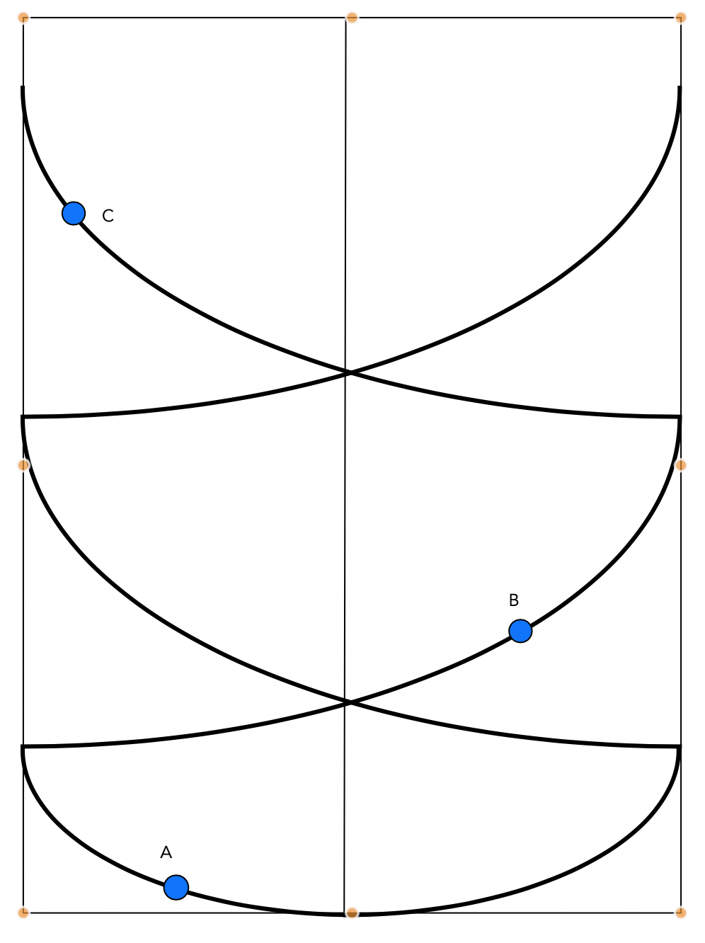
9. Find the time constant associated with the resistivity of copper at 400K. See Figure 25-7. 15

b. Find the mean free path in Å. 5

10. Calculate the Hall coefficient of beryllium. Compare to the experimental value and briefly discuss. 15

